DATA SECURITY RISKS

Method 1 :

A system comprised of KSI, Golem, Path, Skyry and Dapp builder (in finance) can be used to ensure data security.

* Keyless Signature Infrastructure

Uses blockchain. Stores public data securely. Monitors changes to prevent data tampering. Promotes data transparency.

* Golem

Decentralized supercomputer made up of the syndicate powering of user's machines ranging from PCs to entire data centres

* Path

Path is utilized for extra bandwidth. Path Mining Nodes installed on computers provide work insights back to Path.

* Skyry

Detects suspicious activity on the blockchain, eliminates synthetic identity theft

* Dapp builder

Used for data verification in the financial sector

Method 2: Data Anchoring

Data Anchoring allows companies to maintain off-chain database which can be referenced and verified on the blockchain, without the revelation of data stored inside the database.

This allows the companies to detect data tampering without going through the inefficient process of storing entire files and databases on the blockchain.

It can be implemented using the Chainkit service. <https://chainkit.com/data-anchoring>

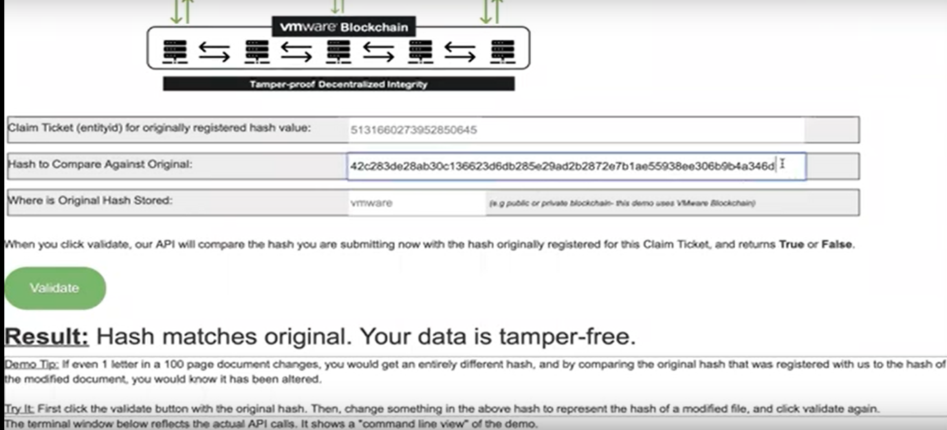

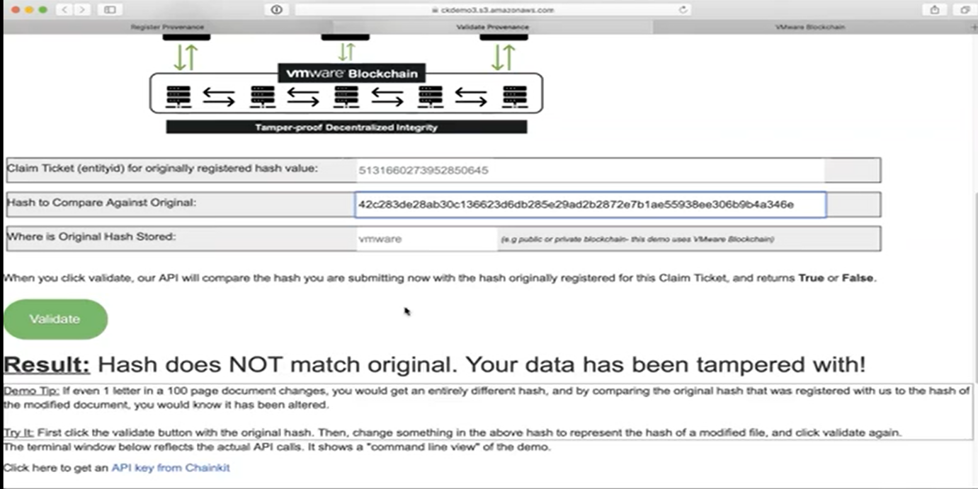

DDOS ATTACK RISKS

Method 1: